Relief fades for migrant Zimbabweans fleeing South Africa
The Zimbabwean by AFP
25 July 2026
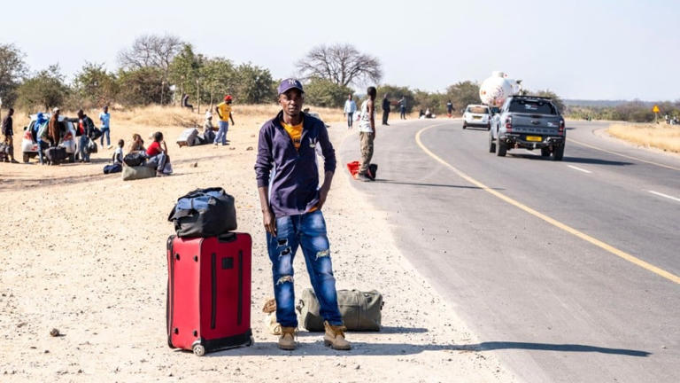
Relief fades for migrant Zimbabweans fleeing South Africa© Provided by The Zimbabwean
Tichaona Magomazi, 35, stands beside his luggage on the roadside outside Beitbridge town on July 10, 2026, after returning to Zimbabwe. ZINYANGE AUNTONY / AFP
BEITBRIDGE, Zimbabwe – Stitches zigzag across the left side of Shingirai Kurebwaseka’s head, after he was badly beaten in a wave of protests against undocumented migrants that have swept South Africa.
The 35-year-old Zimbabwean had his right arm encased in plaster and his left foot supported by a splint and wrapped with a plastic bag.
“They beat me all over, smashed my foot with a hammer, burned me with some plastic papers which they had lit and were going to put a tyre around me but I somehow still managed to escape,” he told AFP.
South Africa — the continent’s wealthiest nation — has long been a magnet for migrants.
But for weeks, it has been swept by protests and deadly violence against foreigners.
Hospitalised for seven days, Kurebwaseka eventually boarded a bus organised by South African authorities for foreign nationals.
Tens of thousands of Zimbabweans have fled South Africa in recent weeks.
Many, like Kurebwaseka, remain at a crowded government-run shelter in Beitbridge supported by humanitarian agencies, including the International Committee of the Red Cross.
“I am in pain and just want to be treated and go home,” Kurebwaseka told AFP outside the shelter’s clinic.
Fringe groups had set an unofficial deadline for undocumented migrants to leave South Africa.
The groups blame undocumented migrants for crime and job shortages — accusations analysts dismiss as scapegoating.
Fellow Zimbabwean Tichaona Magomazi carried all he was able to salvage after 11 years in Johannesburg in a single suitcase as he left South Africa in a hurry.
The 35-year-old may have found relief from fear, but he has little certainty about what comes next.
He stood beside a highway outside the southern border town of Beitbridge, scanning passing vehicles for a ride to the capital, Harare.
He was hoping to somehow make the journey home, despite not being able to afford the fare.
“I left at the earliest opportunity,” Magomazi told AFP. “I have no words for this situation that we are finding ourselves in.”
Forced’ returns
South African police say at least four foreign nationals have been killed in attacks linked to the anti-migrant protests, though some African governments repatriating citizens have reported a higher toll.
The violence has triggered one of the largest waves of exits from South Africa.
More than 73,000 Zimbabweans returned from South Africa between May 28 and July 5, the International Organization for Migration (IOM) Zimbabwe said, citing government figures.
Of these, 54,630 repatriated themselves while 19,048 were assisted through government programmes.
Many arrive with little more than the clothes they were wearing.
“I had to leave hurriedly from where I was staying because the vigilantes were doing house-to-house searches for foreigners,” said Amos Ferenando.
The 41-year-old had spent seven years working in South Africa’s construction industry but was stranded at a highway kiosk, reaching out to relatives for help to make the journey to his rural home in Zvishavane, 330 kilometres north.
“My money ran out because I had to pay fines at the border,” he said.
Rapid assessments at the border found that 69 percent of surveyed returnees described their journeys as “sudden or forced”, IOM’s Fadzai Nyamande-Pangeti said.
“Vulnerabilities increase as movements escalate,” she said, adding that returnees need food, transport and psychosocial support.
For Magomazi, who still clutches the lone suitcase carrying what remains of his life in South Africa, the priority is simply getting home.
“All I am praying for right now is that I get transport to get me home,” he said.
https://www.thezimbabwean.co/2026/07/relief-fades-for-migrant-zimbabweans-fleeing-south-africa/

