In Memoriam: RW (Bill) Johnson – A Fearless Voice for Truth

The Mike Campbell Foundation

27 July 2026

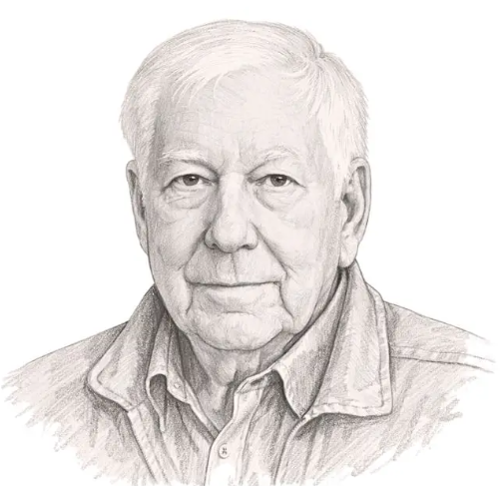

Image credit: The Common Sense

The Mike Campbell Foundation is deeply saddened by the passing of RW (Bill) Johnson, one of southern Africa's most respected political commentators, historians and public intellectuals.

For more than four decades, Bill Johnson combined academic rigour with exceptional journalistic insight, earning a reputation as one of the region's most perceptive analysts of political developments. While his work ranged widely across southern Africa, he will be especially remembered by many Zimbabweans for his unwavering commitment to documenting the country's political and humanitarian tragedy.

At a time when many preferred silence or ambiguity, Bill wrote with remarkable clarity about Zimbabwe's descent into authoritarianism. He chronicled the violent farm invasions, the destruction of the rule of law, the assault on democratic institutions, the brutal attack on the Save Zimbabwe Campaign prayer meeting in March 2007 and the government strategised violence during the brutal 2008 presidential election run-off campaign. His writing consistently reminded readers that behind the political headlines were millions of ordinary Zimbabweans whose freedoms, livelihoods and dignity were being systematically destroyed.

Bill’s articles were distinguished not only by their depth of research but also by their willingness to confront uncomfortable truths. He recognised early on that Zimbabwe's crisis extended far beyond economic collapse; it represented a profound erosion of constitutional government, human rights and democratic accountability. His work provided invaluable context for policymakers, academics, journalists and human rights advocates around the world.

Those of us fortunate enough to have met Bill experienced the same qualities evident in his writing: intellectual honesty, generosity with his time, and an uncompromising commitment to facts. He had a reputation for being immensely knowledgeable and refreshingly forthright. His encouragement and insights left a lasting impression.

Bill was also well known to many South Africans through his frequent appearances on BizNews with Alec Hogg, where his measured analysis and independent thinking earned him a wide and loyal audience.

The Mike Campbell Foundation extends its sincere condolences to his family, friends and colleagues. His scholarship, courage and dedication to truth have left an enduring legacy. His writings will continue to help future generations understand one of the defining political crises in southern African history, while reminding us all of the importance of defending democracy, the rule of law and fundamental human rights.

He will be greatly missed.

27 July 2026

